**Project Initialization and Planning Phase**

| Date | 12 July 2024 |
| --- | --- |
| Team ID | SWTID1720077079 |
| Project Name | Wild Blueberry Yield Prediction |
| Maximum Marks | 3 Marks |

**Problem Statement:**

Blueberry farmers face significant challenges in predicting their yield accurately due to reliance on traditional methods, unpredictable weather patterns, soil conditions, and pest infestations, leading to financial instability from overestimation or underestimation of produce. There is a critical need for a reliable, precise yield prediction system utilizing machine learning to provide accurate predictions that consider various factors such as weather, soil health, and pest activity. This system will enable farmers to plan their harvesting and marketing strategies, optimize resource allocation, enhance financial planning, reduce waste, and improve overall productivity. By addressing these needs, the machine learning-based Blueberry Yield Prediction System aims to offer accurate and timely yield predictions, insights into crop yield factors, data-driven recommendations for crop management, and a user-friendly interface, ultimately contributing to increased productivity, better financial planning, and enhanced sustainability in blueberry farming. Success will be measured by reduction in yield prediction errors, increased farmers' income, user satisfaction, and improved resource utilization.

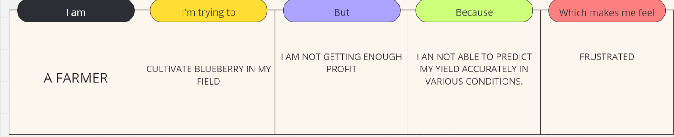

|  |  |  |  |  |  |
| --- | --- | --- | --- | --- | --- |
| **Problem**  **Statement (PS)** | **I am** | **I’m trying to** | **But** | **Because** | **Which makes me feel** |
| PS-1 | Farmer | To cultivate | Have low profits | Of poor yield | Poor |
| PS-2 | Middle man | Buy product from farmers | No fixed income | Of variation in production | Disappointed |
| PS-3 | Consumer | Get the fruits from shop | It may not be available when I want | Of unpredictable production | Malnourishment |